Sample RISK ASSESSMENT FORM EG.06

Events Group/Volunteer Risk Assessment Form. Please complete both sides of this form and return to
your RC / Engagement Officer or the Fundraising Team two weeks prior to the date of your event. Please see guidance to help you completed the risk assessment

Events Group/Volunteer Name: London Events Group – S K Event Type and Date: Christmas Party Saturday 5th December 2018

Date of Risk Assessment: Friday 20th November 2018

What are the hazards? | Who might be harmed and how? | What are you already doing? | What further action is necessary? | Action by Whom? | Action by When? | Completed? (date) | Is the remaining risk Low Medium or High
Slips, trips and falls. | Adults and children - falling down stairs | Make adults aware they are responsible for their children’s safety and welfare | Ensure parents/carers are aware of the hazard as they arrive  Identify and report any accidents to CLAPA representative and nominated First Aider. | SK | 5.12.18 |  | Low
Scalds | Adults and children – hot drinks | Make adults aware they are responsible for their children’s safety and welfare | Ensure a volunteer is present near the hot drinks so that they are kept out of the reach of children.  Identify and report any accidents to CLAPA representative and nominated first aider. | SK | 5.12.18 |  | Low
Unfastened external door | Children – alone outside, near busy road / car park | Make adults aware on arrival, that external doors MUST be securely closed at all times, for reasons of child safety. | Place a volunteer near the door as people arrive | SK | 5.12.18 |  | Low
Food Allergies | Adults and children – sudden and/or severe allergic reaction | Booking form has a required field for dietary requirements.  Make adults aware they are responsible for their children’s safety and welfare. | Known ‘risk’ foods to be clearly identified and labelled.  Identify and report any incidents to CLAPA representative and nominated first aider. | SK | 14/09/18 |  | Low
Photography | All | Booking form has a required field for photo consent.  Families are asked again about photo consent at sign in desk. | Welcome volunteer reminds families about photo consent | SK | 5.12.18 |  | Low

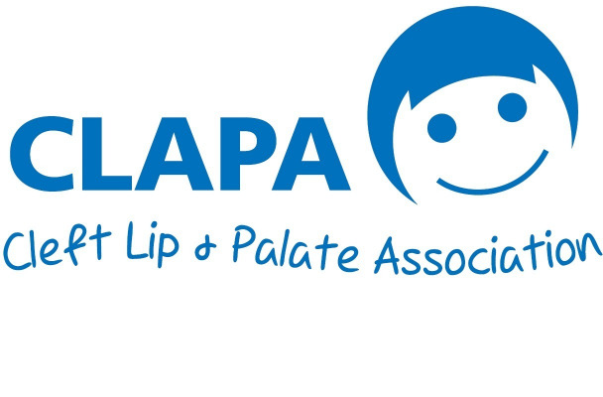Registered Charity England & Wales (1108160) and Scotland (SC041034)

